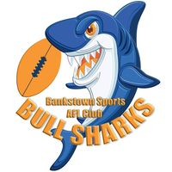

Formal Statement of Commitment:

The Bankstown sports AFL Club is committed to promoting and protecting the safety and wellbeing of all children and young people who participate in our games, activities, programs, services and /or use our facilities by fostering a culture where children and young people feel safe and welcome.
Footy should be safe for children and young people.
At Bankstown sports AFL Club we are committed to this.
Be safe. Feel safe. Play safe. ‘Say something’
At Bankstown sports AFL Club, we all play a role in protecting our children and young.
Everyone has a responsibility to say something.
If you or your child has any concerns that they would like to raise in regards to their safety or wellbeing, please reach out to the Clubs Child safety support officer
– Mick Whitham (Vice President);
or any member of the bullsharks committee.

Abuse in sport can look and feel different for different people. Find out how you can recognise what abuse may look like in a footy environment here. Abuse in footy

Find out how to raise a concern by clicking: Raise a concern

Did you know the AFL has translated some of its key safeguarding resources into 6 community languages, including Arabic, Chinese Simplified, Tagalog, Vietnamese, Hindi and Dinka.
Language guides

